**RFID BASED SMART TROLLEY**

**Ashwine1, Subhash NR2, Yashas M Lokesh3, Sreelatha KS4, Prof. T. Sushma5**

UG Students, Electronics and Instrumentation, Dayananda Sagar College of Engineering, Bengaluru, India

Associate Professor, Electronics and Instrumentation, Dayananda Sagar College of Engineering, Bengaluru, India

**E-mail:** [1ashwine131@gmail.com,](mailto:1ashwine131@gmail.com,) [2nrsubhashvrm@gmail.com,](mailto:2nrsubhashvrm@gmail.com,) [3yashaspmlokesh@gmail.com](mailto:3yashaspmlokesh@gmail.com) , [4sreelathakamble951@gmail.com](mailto:4sreelathakamble951@gmail.com) , [5sushma-it@dayanandasagar.edu](mailto:5sushma-it@dayanandasagar.edu)

_____________________________________________________________________

**ABSTRACT**

In metro cities we can see you a huge rush at shopping malls on holidays and weekends. This becomes even more when there are huge offers and discounts. In such situations, when you want to buy only a handful of stuff, it becomes very annoying to look through the entire store to find them. We eventually ask the people employed by the store to help us but that too is bit time consuming since the stores now a days are really huge and big. Now a days people purchase a variety of items and put them in the trolley. After total purchasing one should approach counter for billing purpose.

By using bar code reader the cashier prepares the bill which is a time consuming process .This results in long queues at the billing counters. This project presents an idea to develop a system in shopping malls to overcome the above problems. To achieve this all products in the mall should be equipped with RFID tags and all trolleys should be equipped with a device which we have made to accelerate the whole process of shopping.

Further there is an android application that we have made as a part of this project. After entering the store, we just need to connect the Android application to the device fitted on the trolley using the Bluetooth and simply start moving through the aisle. Whenever we wish to buy a product which we earlier added to the cart of our android application is present, the device will notify us regarding this. When one puts any product in the trolley its code will be detected automatically , the item name and cost will be displayed on the application, thereby the cost gets added to the total bill. If we wish to remove the product from the trolley, you can take away the product and the amount of that specific product gets deducted from total amount and the same information passes to the application via Bluetooth module. Hence the billing can be done in the trolley itself thereby saving a lot of time to the customers.

**KEYWORDS:** RFID reader, Arduino , IOT, Smart trolley, Shopping smart, Ultrasonic Sensor.

1. INTRODUCTION

**1.1** **Background**

Individuals have constantly created innovations to bolster their requirements as from the start of humankind. The fundamental reason for development in innovation is ought for more independence and this leads to improving tasks and making regular one simpler and speedier. One significant task that individuals invest maximum measure of energy is in shopping. Shopping center is a spot where individuals get their every day necessities running from sustenance items, garments, electrical machines and so forth.

Sometimes clients have issues with respect to the unspecific data about the item marked down and misuse of superfluous time at the counters. In this innovative world, each grocery store and supermarkets utilize shopping trolleys with a specific end goal to help clients to choose and store the items which they expect to buy. Customers usually purchase the products required and place them in their carts and thereafter wait at the counters for payments of bills. The payment of bills at the counters is really troublesome and time consuming process which thereby increasing a heavy crowd at the counters.

**1.2 Purpose of Project**

The fundamental motivation behind this system is to show the proposition of a design and arrangement of an inventive framework for obtaining of items in markets . This cart explores rising versatile innovations and programmed recognizable proof advancements, (for example, RFID) as an approach to enhance the nature of administrations given by retailers and to expand the customer esteem consequently permitting to save time and cash. With this device an excellent opportunity will be developed which assists the customers by showing the catalog of products and their respective costs.

This approach thereby helps the inventory management unit with an instinctive upgrade on each purchase of product. This smart cart has the capability to make shopping more relaxable, comfortable and systematic for the customers as well as making it easier for the store management. Further it doesn’t require the extra staff to handle the customers, so profit margins can be increased for store owners.

1. LITERATURE SURVEY

The RFID based smart trolley consists of trolley that incorporated with RFID reader. As soon as the customer place the product they want to buy into the trolley, the RFID reader attach to the trolley detect the RFID tag number of the product to identify it. Each RFID tag number is linked to a product it describes. All the information regarding the product associated with the RFID tag is in database can be retrieved using centralized server.

All the activities are coordinated together using a Node MCU. The product can be directly scanned by the reader and if the customer wishes to remove any product, they just have to again scan the product, then the product should be deleted. After the purchasing product total amount of bill generated and display on LCD of the trolley and also at the billing section. When customer goes to billing section he has to only pay the amount.

1. PROPOSED WORK:

3.1 Components Used:

Hardware Tools:

1. MFRC522 RFID Module
2. ARDUINO UNO
3. I2C Module
4. 16*2 LCD Display
5. LED: Light Emitting Diode
6. Buzzer
7. RFID Tag
8. RFID Card

Software Tool:

1. ARDUINO IDE

3.2 System Architecture:

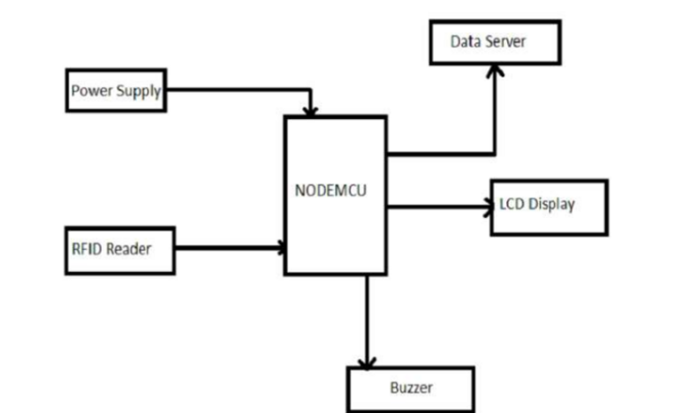

Figure 3.2: Block Diagram of System Architecture

3.3 Algorithm:

**Step1:** Start.

**Step 2:** Put the product attached with RFID tag into trolley.

**Step 3:** RFID reader reads the tag information.

**Step 4:** The Node MCU sends this information to the server.

**Step 5:** The server stores the information in the database.

**Step 6:** The total amount is calculated into the server.

**Step 7:** Final amount get displayed in the server.

**Step 8:** Payment of the bill.

**Step 9:** The database is updated.

**Step 10:** Stop.

**3.4 Flowchart:**

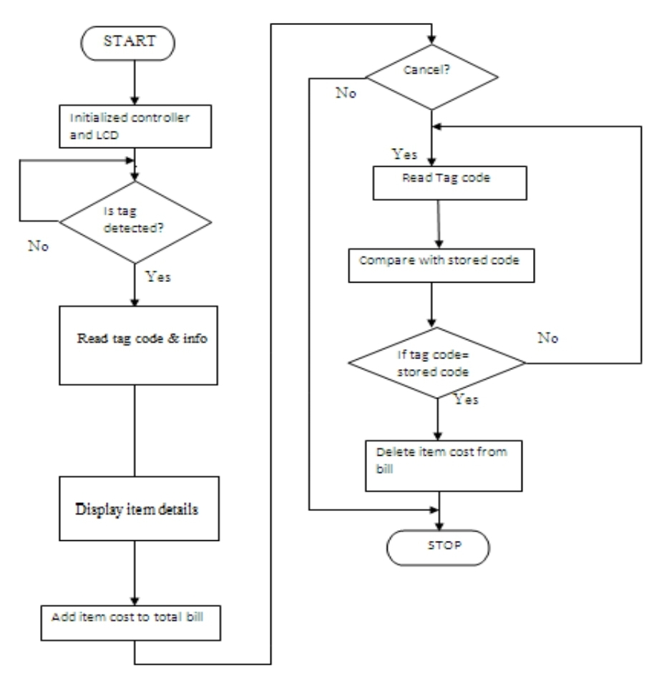

**Figure 3.4: Flowchart of the working process**

1. RESULTS AND DISCUSSION

4.1 Existing system:

In the existing system, they have used the traditional method of barcode scanning. Using the barcode scanner we need to scan each product and so this method becomes very slow to be scanned. A barcode reader is associate in electronic device for reading with the barcodes. In this process we have no automatic billing system and the customer has wait for the billing process in the long queues. Therefore, using the barcode process billing method is slow. This eventually results in the long queues.

To avoid the process, we introduced types of technology is the RFID based billing system. User can pay the amount through credit/debit cards or by cash. But it is the time consumption process for the billing purpose. So, the waiting time to pay the bill is increased.

To overcome, the time consumption process the RFID based smart trolley system is proposed.While the customer keeps the product in the smart trolley, the Radio frequency ID reader automatically senses the product by scanning the tag. And its corresponding electronic product code number is generated automatically. To store the item price and total billing data, microcontroller memory is used LCD display. This electronic product code provides the information of the product its name and price.

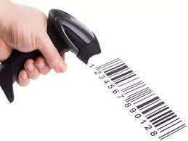

Figure 4.1: Barcode Scanner

4.2 Proposed System:

In the proposed system, once the customer purchased the product, they have to first scan the RF tag using the RFID reader and then place it in the trolley. When the customer scanning the RF tag of the product, a price of the product is taken and stored in the systems memory.If matches are found then the cost and the product name gets displayed on the LCD. At the same time the processor sends the same information to computer for billing purpose with the help of RS232 protocol.

In this proposed system we are also using the IR senor for counting the product for security purpose. This will not have any addition of cost product in bill. If any unwanted product is removed from the trolley, then it will reduce the count in the bill and recalculate the amount based on that. Through the RFID tag, the scanning purpose will be done in less time and there is no need of human labours. The name and price of the product will be displayed on the LCD of the smart trolley by the controller.

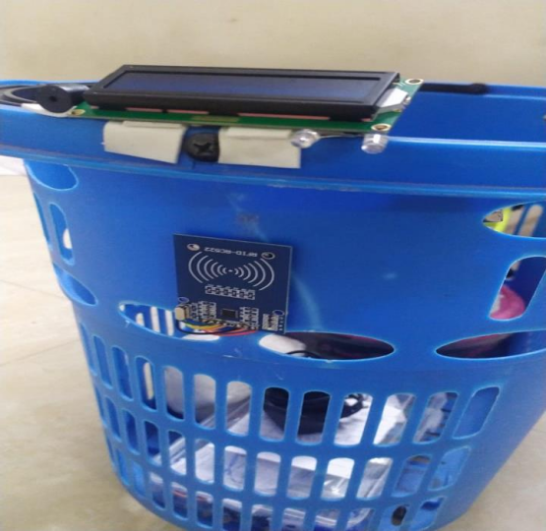

Figure 4.2(a): Side view of the proposed system

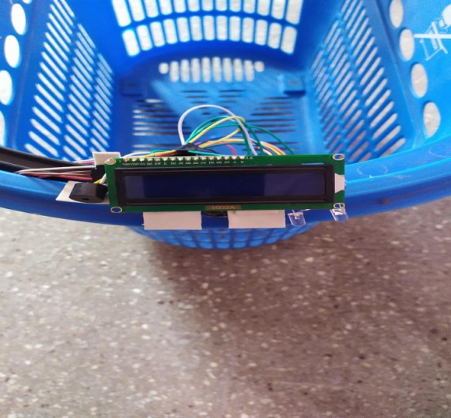

Figure 4.2(b): Top view of the proposed system

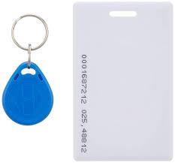

Figure 4.2(c): RFID tags

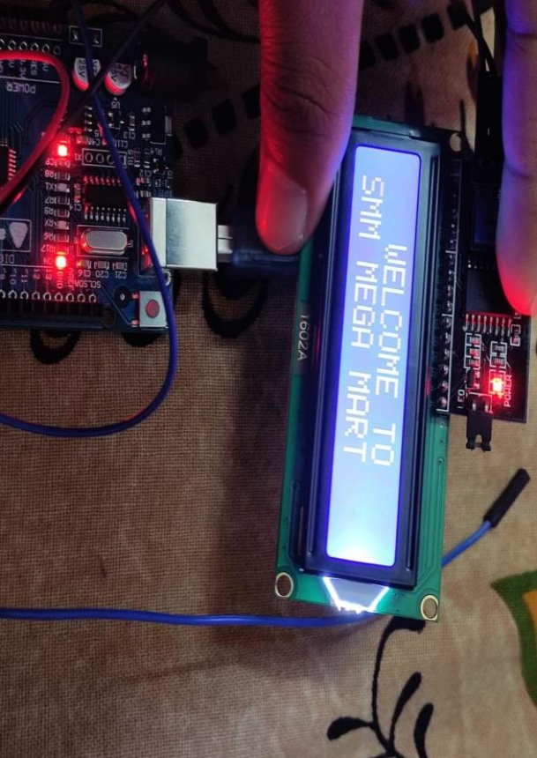

Figure 4.2(d): LCD Screen

Results

The proposed model is easy accessible and convenient to use. It does not require special training. The manpower is decreased and will save time that the user spends in billing queue. Many users can be attended in same time which is useful for retailers and customers. Time efficiency and cost efficiency are guaranteed by this smart billing system.

1. CONCLUSION

The advancement in science and technology is a persistent process. Latest gadgets and latest technology are being designed and developed . This application is used in shopping malls for assisting customers by saving a lot of time in buying commodities. In this project RFID is used as safety access for the item which thereby enhances the

surveillance performance. This implementation initiates for an automated central billing system in shopping malls and supermarkets. With this, shoppers no longer have to wait near counters for payment of bills because of their purchased item information getting transferred to central billing unit.

By this billing process speed increases and becomes much more simpler. In addition to this capability, the mechanism also assures recognition of cases of theft induced by fraudulent consumers which makes the system more reliable and fascinating to both customers as well as sellers. This will enhance the shopping experience to a new level. Different variables like item cost, item name etc are continuously displayed on LCD attached to the trolley. Thus we can say that automatic billing of products by using RFID technique will be a more feasible choice in the upcoming days and thereby operation becomes more concise and systematic. The objective is effectively attained in the prototype model developed.

The developed product is of low cost, amiable to use and does not require any specific practice. The ability to take a decision can be done in the cart itself which can be used in the shopping complexes for effortless and clever way of purchasing items to save vitality, time and money of the customers. The project is evaluated with different trial cases with distinct items assessed for all the practical trials.

Tags used in this project are water sensitive so the trolley is restricted to use water sensitive products. And moreover tags used in this project have the capacity of detecting only one side therefore tags are attached to products in circular fashion in order to avoid non detection .If we can use more powerful tags which are under research, we can overcome this problem. When the evaluation is done with a single shopping trolley with distinct items , it gives the 83% accuracy for all the cases.

**FUTURE SCOPE AND LIMITATIONS**

In spite of the fact that the RFID can't totally supplant the standardized identification innovation because of higher cost precision and speed is high in RFID implementation. The retailers, makers and purchaser products organizations like CVS, Tesco, Prada, Benetton, Wal-Shop and Procter and Bet are presently actualizing the innovation and investigating the effect of the innovation on their business.

Others can likewise implement RFID. The basis of accomplishment lies in understanding the innovation and different components to minimize the potential issues. It is time for the Industry ought to begin using the new innovation, for example, RFID in different applications, for example, fabricating, and storing purposes. In this project the items in the cart is restricted to less than 50 as the customers don’t prefer excess luggage at once. Tags used here can be attached to the products only in the longitudinal fashion without any folds .

Tags given for the reader are of length 8cm and of width 2cm and they need to be attached to the products in a visible fashion for the reader then only the reader can detect tags without any fail. Tags used in this project are water sensitive and metal . So the trolley is now restricted to use water sensitive packaged and metal sensitive packaged products. But the problem can be rectified with the waterproof tags and metal resistant tags which are under research at present. And the multiple object RFID reader used here has the constraint of skipping the tags at sometimes. Reader which can detect less than 50 tags/sec is employed according to the requirement and meanwhile cost will also be under control for implementation of system.

**REFERENCES**

[1] Komal Ambekar, Vinayak Dhole, Supriya S Smart Shopping Troll Using RFID International Journal of Advanced Research in Computer Engineering & Technology, (IJARCET), Volume 4 Issue 10, 2015.

[2] K.Gogila Devi, T.A.Kaarthik, N.KalaiSelvi, K.Nandhini, S.Priya, Trolley Using RFID Based on IoT International Journal of Innovative Research in Computer and Communication Engineering. Vol. 5, Issue 3, 2017.

[3] Zeeshan Ali,Reena Sonkusare,"RFID based Smart Shopping: An Overview" in International Conference on Advances in “Communication and Computing ” Technologies ,Issue in 2014.

[4] Prasiddhi K. Khairnar,Dhanashri H. Gawali,"Innovative Shopping Cart For Smart Cities " in IEEE International Conference On Recent Trends in Electronics Information & Communication Technology (RTEICT), May 19-20, 2017, India.

[5] Mr.P. Chandrasekar,Ms.T. Sangeetha,"Smart Shopping Cart with Automatic Billing System through RFID and ZigBee" in IEEE S.A.Engineering College, Chennai, Tamil Nadu, 2014,India.

[6] Akshay Kumar, Abhinav Gupta, S. Balamurugan, S. Balaji and Marimuthu R., "Smart Shopping Cart" in School of Electrical Engineering, VIT University,Vellore IEEE,2017. Department of Electronics & instrumentation 24 RFID BASED SMART TROLLEY 2021-2022.

[7] Ruinian Li, Tianyi Song, Nicholas Capurso,"IoT Applications on Secure Smart Shopping" in International Conference on Identification, Information and Knowledge in the Internet of Things,2017.

[8] Tharindu Athauda, Juan Carlos Lugo Marin, Jonathan Lee, Nemai Karmakar,"Robust low-cost passive UHF RFID based smart shopping trolley" in IEEE Journal of Radio Frequency Identification,Issue in 2018.

[9] Rajlakshmi Badi, Bashirahamad Momin,"SISC: Sensor-based Intelligent Shopping Cart" in 3rd International Conference for Convergence in Technology (I2CT),Apr 06-08, 2018 India.

https://www.youtube.com/watch?v=dXZiFx6RP6s&t=276s

[10] https://www.instructables.com/id/ESP8266-Building-Blocks-Send-Data-to-a-Web-Server-/

[11] https://www.instructables.com/id/ESP8266-Communication-With-Server-and-ESP8266/

[12] http://forum.arduino.cc/index.php?topic=544342.0

[13] https://electrosome.com/em-18-rfid-reader-arduino-uno/

[14] https://circuits4you.com/2018/10/03/rfid-reader-rc522-interface-with-nodemcu-using-arduino-ide/